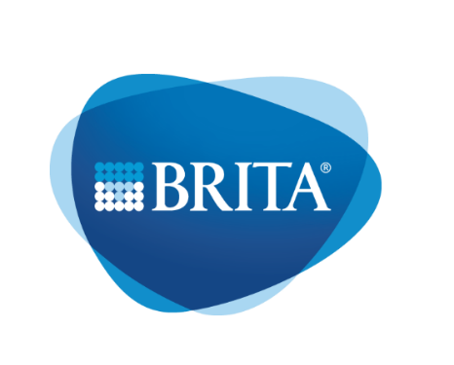
Maintenance Protocol
Version: 1.1 (10/2020)
Machine Type: Serial Number:
Customer:
Technician Name:
Service Report No: Date:
Functional test |  | Remark on error
Check device for function: Tap all types of water, Check alarm list
Measurement of electrical safety according to DGUV v3
Optical inspection for leaks
Cleaning
Carry out dry cleaning (according to the instructions in Dozuki)
Cleaning of the device inside and outside
Cleaning and descaling the taps and the drip tray
Cleaning the cooling fins
Checking the device
Check for external damage
Check for completeness of the system
Checking the sewage connection
Checking the water connection
Water tightness test
Testing the water flow
Testing the water pressure reducer
Testing the C02 connection
Test C02 pressure reducer incl. pressure relief valve
Testing of the C02 tightness
Testing of the hose cross sections
Testing the carbonator pump
Only Vivreau Fill 200: Check Kalibration Nozzle 1/2
Only Vivreau Fill 200: Check ice bank level
Exchange of maintenance relevant components
Replacement of water inlet filter (insert pre-rinsed in the course of chemical cleaning)
Only Option Hygienic Plus: change X3 Filter
Exchange HMI battery (every 4 years, only Vivreau Top/Extra/Fill)
Final activities
Measurement of electrical safety according to DGUV v3
Check device for function: Tap all types of water, Check alarm list
Entry in operating log / cleaning proof
Maintenance sticker attached
Service report signed by the customer

