Service memo
09-02-2026

Number: JDE 2026-01
Dispenser(s): SOUL 10-12
Title: New Cacao Fantasy needs flat insert

With this service memo I would like to inform you that with the new Cacao Fantasy BLUE it is possible that the next insert (black part) of the Cacao canister gives problems. The possibility is that the Cacao will not come out of the canister.
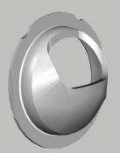
The advice is to use the flat insert with the new Cacao Fantasy Blue as shown below and measure the amount Cacao is correct.
