Service memo
4-4-2025

Number: JDE 2025-01
Dispenser(s): Schaerer Procare
Title: Conductivity sensor with new software

With this service memo I would like to inform you that the conductivity sensor with
SAP number 55126805 will be phased out and a new sensor with new software is available with SAP number: 55128300.
With this software the sensing of the sensor has been improved.
Old sensor (55126805) looks like this::
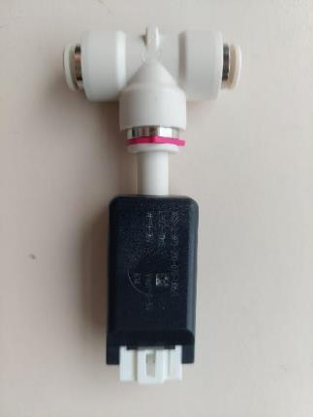

NEW sensor (55128300) you can recognize due to a mark on the connector (xxx700) like on the picture below:
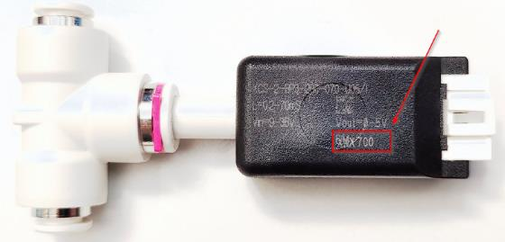

Please change only the conductivity sensor in case of problems.
If Procare works ok change is not needed.

IMPORTANT:
For stock you can order a new sensor (55128300) and
send the old sensor (55126805) back to the warehouse in Venlo (Logical).

