Service memo
11-12-2024

Number: JDE 2024-10 update
Dispenser(s): Schaerer SKYE
Title: Schaerer Skye new valve and twin milk available

From week 27 there is a ‘new’ valve installed in the Schaerer Coffee Skye.
Due to this new valve it is also possible to have twin milk on the SKYE.

For single milk valve 16 Switch over valve (55125958 (100394), 3mm) in the picture below is replaced by 55126719 (101060).

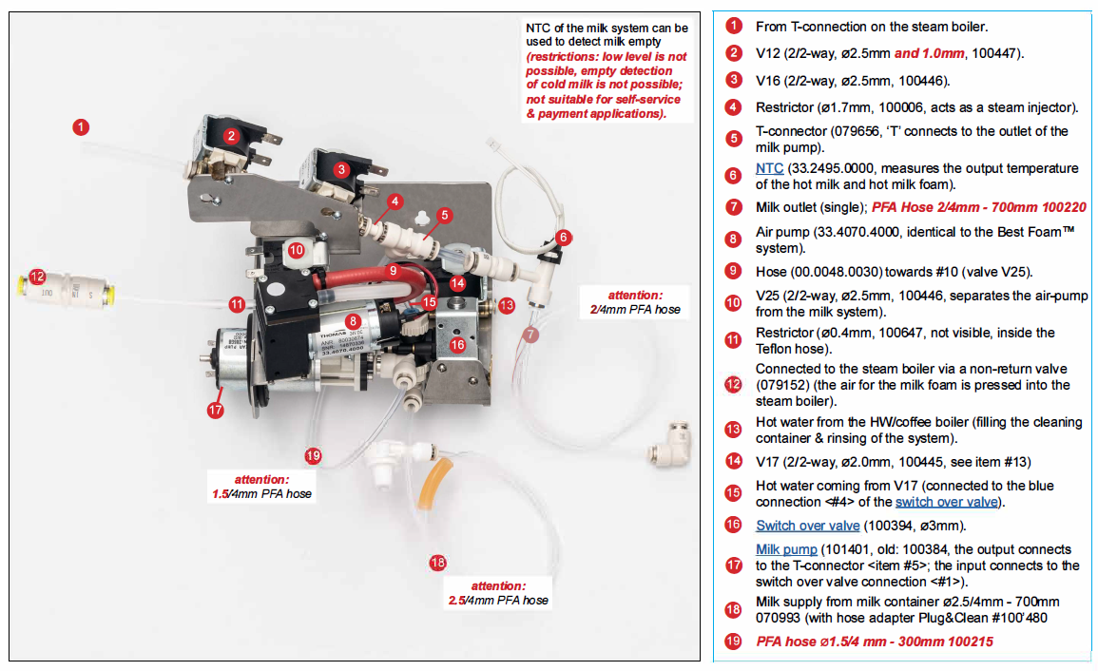

Skye twin milk:
After week 27 it is also possible to have twin milk in the SKYE.
If you want to have this you have to rebuild like described below:

You have to add an extra valve 55126719 (so now valve 1 (V18) and 2 (V20) are for twin milk) to the system and do a hardware detection.
Hardware looks like:
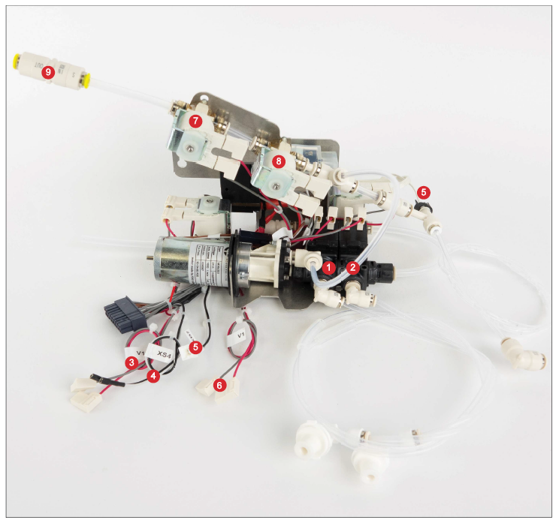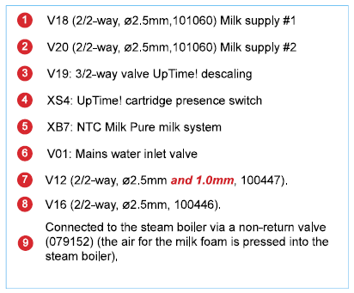
Wire from V16 (valve before week 27) will be connected to V18 and V20 has to connected by the not used wire, see below:

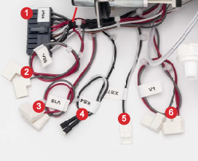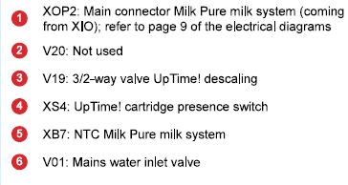
Extra needed beside the valves for the Fridge:
1x 55124937 Milk container bracket TM
1x 55116941 Riser pipe 260 milk container
1x 55119848 Hose adapter Plug & Clean 2K
2x 55124936 Milk container 5l

