Service memo
22-10-2024

Number: JDE 2024-09
Dispenser(s): Schaerer Coffee Club
Title: Schaerer Coffee Club Retrofit instruction telemetry

Below you will find a description how to install the modem in the Schaerer Coffee club:
55127440 retrofit kit gateway eu

The modem is installed on the left side, at the back.   Fix angle with two screws at the coffee machine.   Connection serial and power supply    Connection Ethernet left bushing | 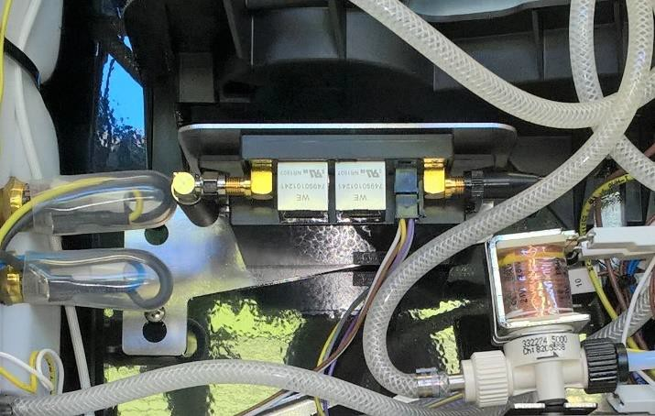
Assembly situation and cable laying serial   and power supply.  | 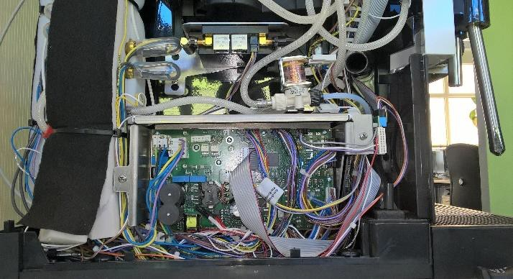
Cable laying Ethernet  | 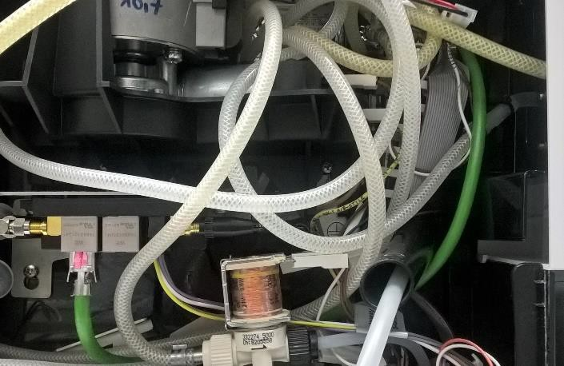
Guide Ethernet cable through rubber bushing… | 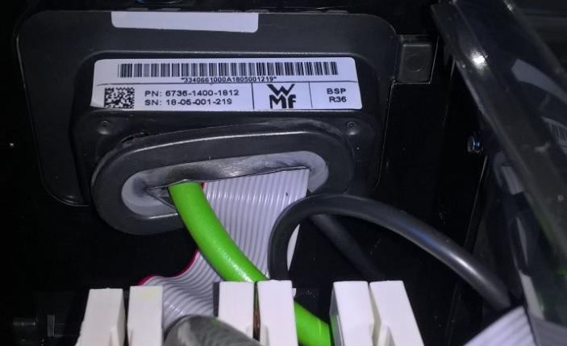

…and plug the Ethernet cable into front panel.  | 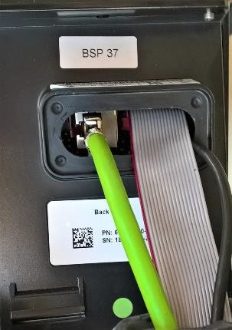
The cable for serial connection is plugged onto the plug „XRDA“.  | 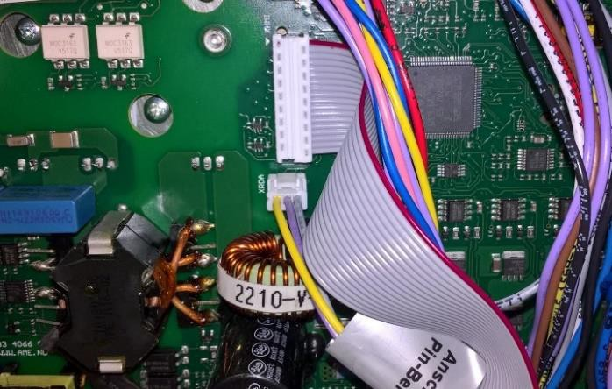
Remove plug of milk cooler empty sensor from housing…  | 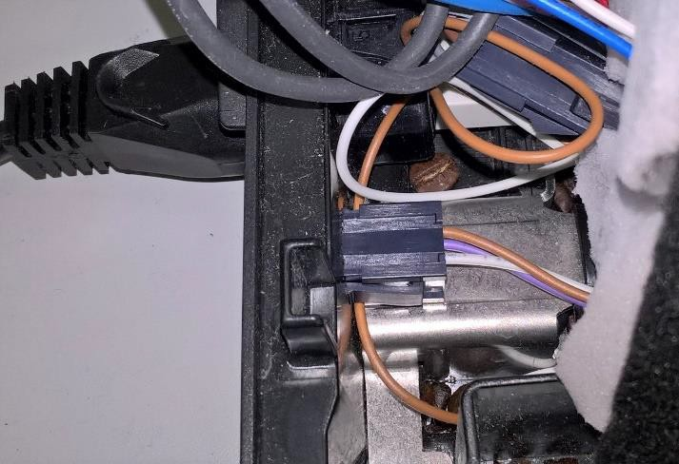

and plug the Y plug between plug of milk cooler empty sensor and housing.   Fit Y plug at housing again (w/o illustration)  | 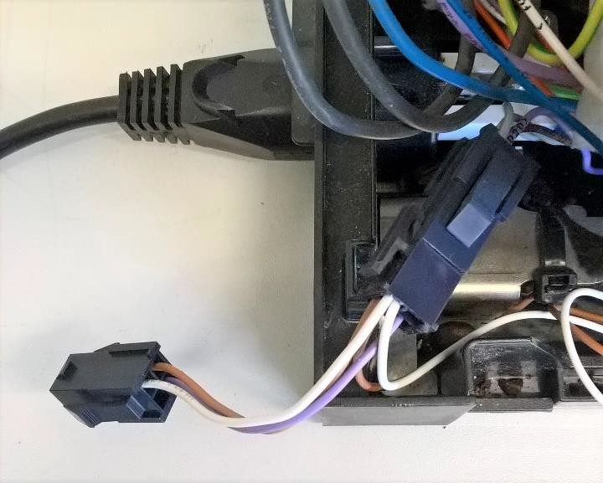
Attention!  If there is still an older modem with independent power supply installed in the machine, it needs to be dismantled and the power supply cable (230 V) needs to be secured (insulated) with a 3-pole luster terminal and must be fixed at the cable harness! | 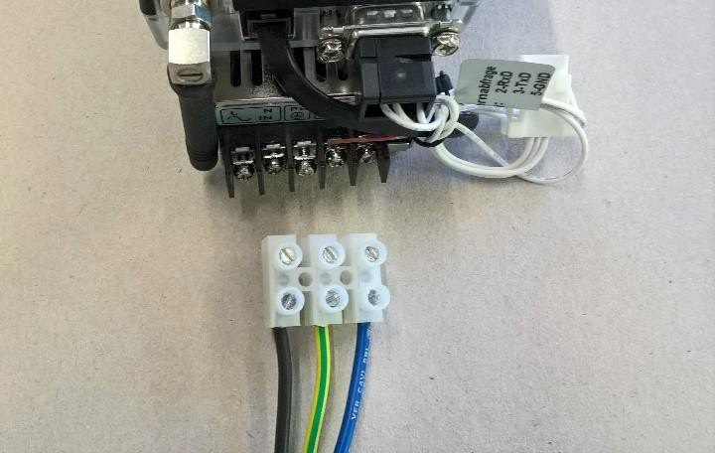

Software Settings
Set NGx3 in the machine settings:
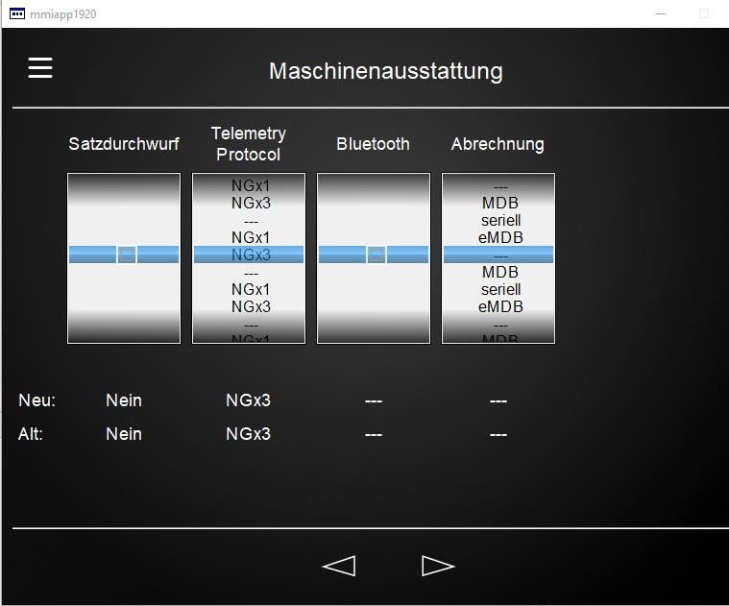

Display of System Information:

As of NGx3 the status is displayed at the coffee machine.  Info -> Service -> browse until the following is displayed:  If it says at „Telemetry Status:“ CONNECTED, modem is connected to server and retrofitting has been successful! | 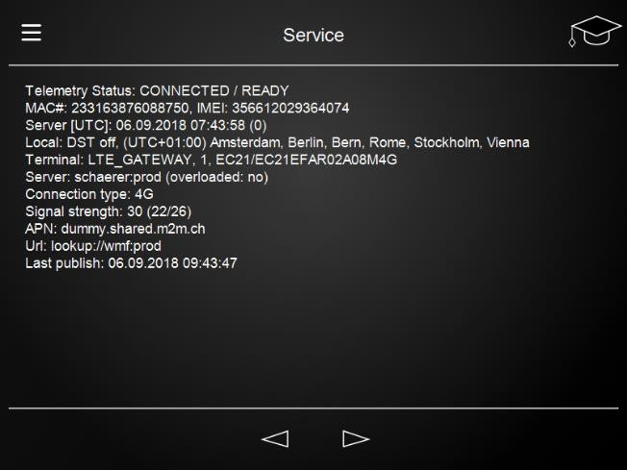
NGx3 protocol version in „Telemetry“ (line 10)  Info -> Service -> browse until the following is displayed:  Under Telemetry the version of the NGx3 protocol is displayed.  | 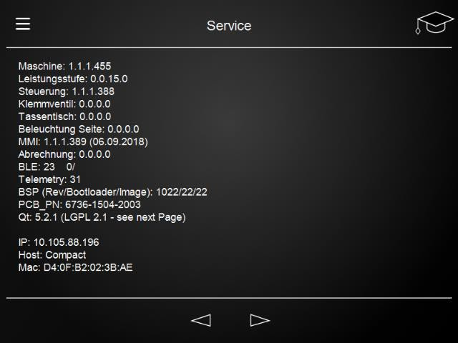

Description of Information on Display

Parameter | Value(s) | Description
Modem link status: | * Connected Connecting None  Idle Error | Connected - Modem is linked to GSM network and connected to InsideM2M server.  Connecting - Modem tries to link with GSM network  None - Stack not initialized (right after restart)  Idle - Stack initialized  Error - Error
Modem status: | Ready  Queue Full | Ready – Connection between PCM (CPU) and modem in order  Queue Full - Modem not ready, because too much  data has been sent by PCM („overflow”)
GMS connection status: | Roaming Idle  Home network Searching Denied Unknown | Roaming – linked to GSM third party networks  Idle - not registered (idle)  Home network – linked to GSM home network Searching – not registered / searching for GSM network  Denied – Registration in GSM network denied  Unknown - Registration status unknown
GMS signal strength: | 19 (Avg/Min/Max: 19/0/24)
Server [UTC]: | 20.04.2018 09:25:32
Time diff: | 2
MCC: | 262
MNC: | 2
LAC: | 8191
CID: | 53841
ICCID: | cid
APN: | internet.gdsp
MAC#: | … | (Hardware-) number of modem
IMEI: | … | number of SIM card
Last pulish: | 20.04.2018 10:25:05
Url: | lookup://Schaerer.int | lookup://WMF.int, lookup://Schaerer.pro, lookup://WMF.pro
* Connected = everything in order.

