Service memo
9-10-2024

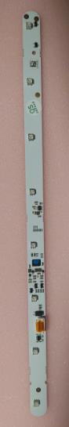
Number: JDE 2024-07
Dispenser(s): SOUL 10-12
Title: LED STRIPS USER PANEL

With this service memo I would like to inform you about the availability of the LED STRIPS USER PANEL for the SOUL 10-12.
SAP number is: 55128066 LED STRIPS USER PANEL

Exchange the LED STRIP in case the colour is wrong, below the steps how to do it:
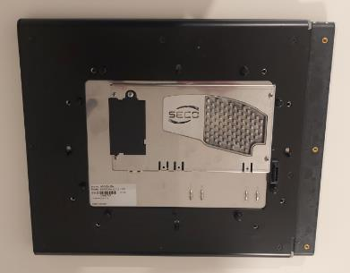
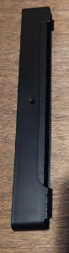
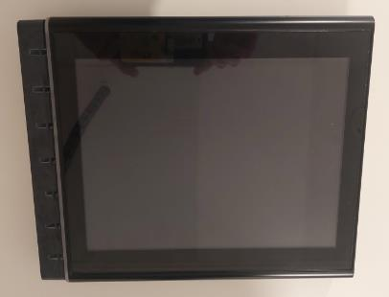
- Take the screen from the machine, 8 screws at the back - Take of the cover at the LED strip side

- Take of the black elastic away
- Unscrew 8 screws at the back of the panel
(red circles)
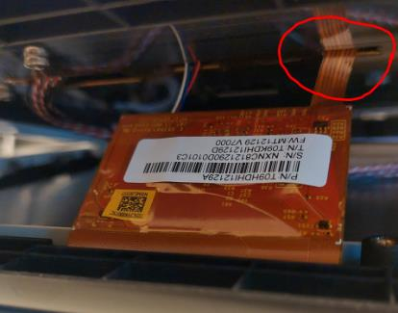
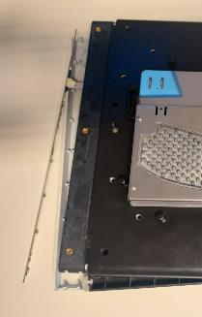
- Now open carefully (watch out for the flat cable) the cover like on the pictures below:

- Exchange the led strip and build the screen back together and into the machine.

