Service memo
19-09-2024

Number: JDE 2024-06
Dispenser(s): Schaerer Coffee Club and Skye
Title:

With this service memo I would like to inform you about a change for the double instant outlet.
The SAP number will stay the same: 55126774 HOLDER RESTRICTOR TWIN POWDER CONT.
Changes are marked with a red circle in the pictures below and will avoid leakage of instant product by the outlet
OLD: NEW:
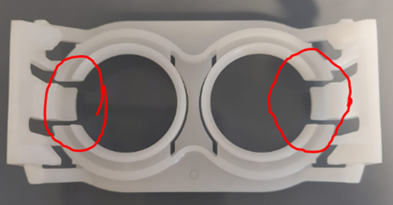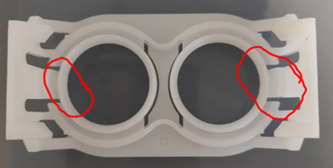
Stock in Venlo is checked.

