Service memo
26-02-2024

Number: JDE 2024-05
Dispenser(s): Procare
Title: Procare Unit Change 55126419 PROCARE SOUL SM BLK KIT RIGHT JDE

With this service memo I would like to inform you about some changes for next procare unit:
55126419 PROCARE SOUL SM BLK KIT RIGHT JDE
Changes for 55126419:
- The vendor material number changed from 040447-00000007 into 040447-00000039
- Description will change from PROCARE SOUL SM BLK KIT RIGHT JDE into:
PROCARE SOUL SM BLK KIT R/L JDE
- Reason for this changes (point 1 and 2) is that 55126419 is now also usable for the left side if it is not possible to have the fridge+procare unit on the right side, which is preferable.
- Difference with the ‘old’ unit is that the new side right panel for the machine is not in the kit (55126419) anymore. This is replaced by a template for drilling a hole on the right place for connecting the procare unit to the machine. Example of the template see below:
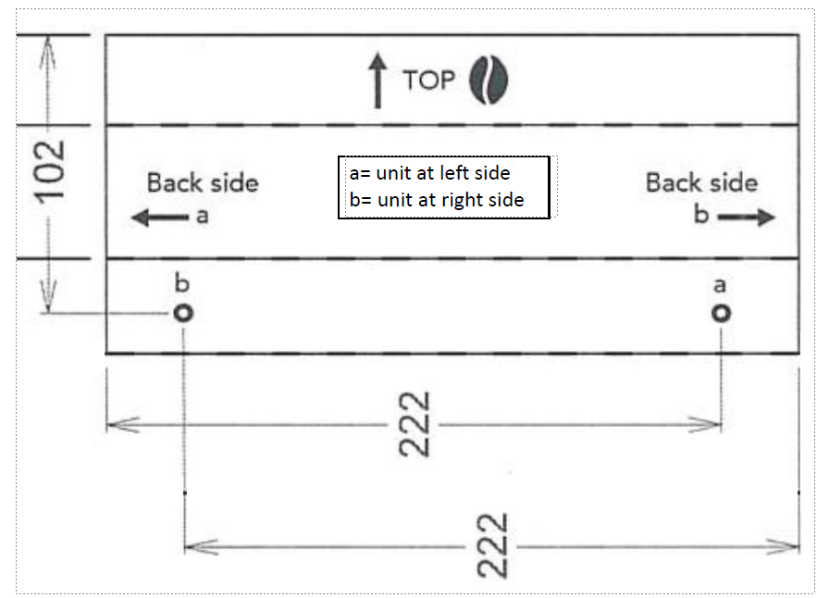
- As the change of description and vendor material number will be done immediately you have to be aware that there are some units (by the moment of making this service memo 36 pieces) on stock which will still have the side panel for the machine inside and not the template. These units can also be used for right or left but then you have to measure by yourself as the template is not inside.
In addition to above also want to inform you that the connection plate (see below picture) is improved so the procare unit is better fitting to the machine.
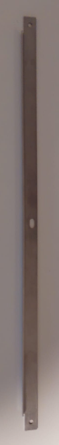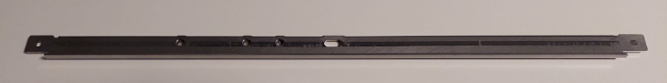
OLD NEW
There are some Procare units on stock with the old connection plate. If you have problems with connecting Procare to the machine please contact your responsible contact person within JDE Equipment operations so that person can arrange a new connection plate. This plate is officially not available as spare part. Is always with the new Procare unit.

