Service memo
15-02-2024

Number: JDE 2024-04
Dispenser(s): Procare
Title: Procare tips

With this service memo I would like to inform you about some tips which can help you out by operating the Procare unit.
- Refill / Reconditioning pouches:
Before starting to reconditioning a pouch press the air out of the pouch by squeezing it.
A small amount of air and sometimes cleaning agent is coming out the small hose located at the arrows in the photo:

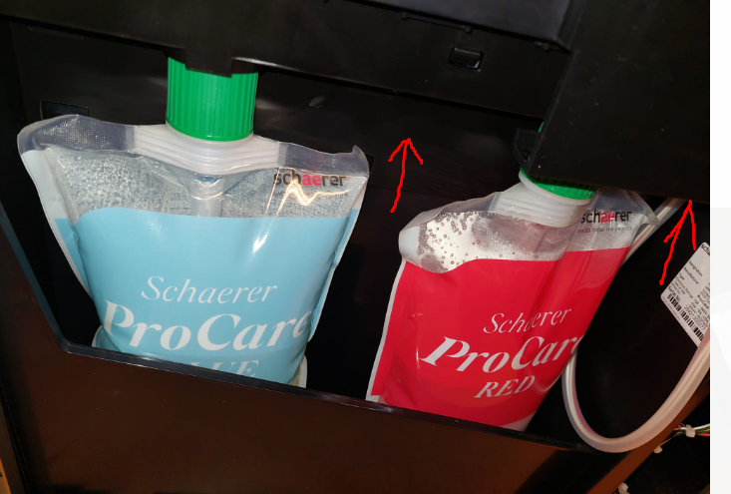



Now start the menu and push location A.
Then push B maintenance menu and start the reconditioning program:
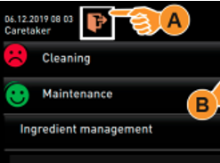
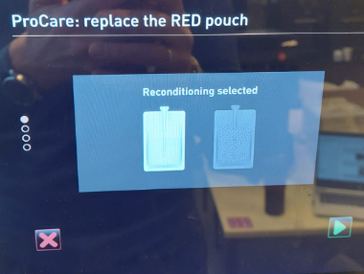

- Reset counters of the pouches in the menu if they are not correct:
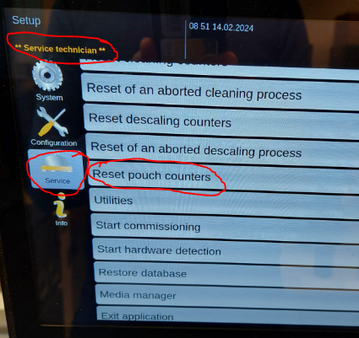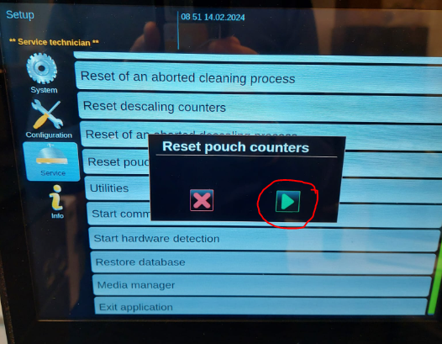
With the next software (5.24 or higher which is planned for March, last estimation) the counter should work better.

- If air gets into the pouch like in the photo below, you can loosen the pouch by turning the green part, twist the pouch slightly and then tighten the green part again. After this you have to proceed a reconditioning of the pouch as described in point 1.
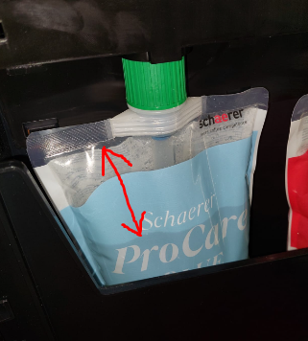

- Small amount of air is NO problem, see photo:
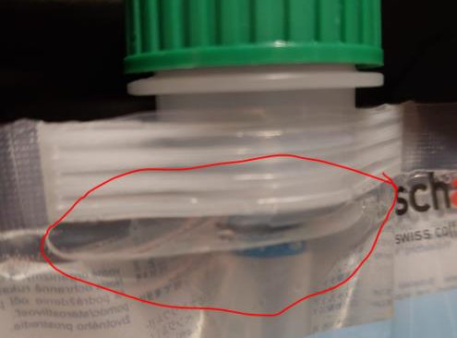
- Use the lock of drip tray if it is not closing properly:
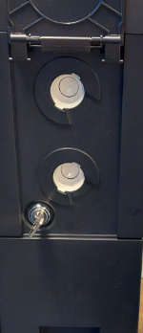

- Spout cleaner 55118983 for milk lance:

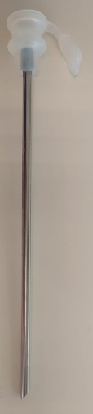
55118843 MILK LANCE/PIPE WMF 1100S (23 cm)
55125736 MILK LANCE INOX 220MM CPL. (22 cm)

