Service memo
17-01-2024

Number: JDE 2024-02
Dispenser(s): Schaerer Procare
Title: Schaerer Procare drip tray sensor adjustment

With this service memo I would like to inform you what to do if the drip tray sensor of the Procare unit give drip tray full or drip tray not in place after installation. We have seen a couple of Procare units with this problem and already informed Schaerer.
To solve this you can do next things:
- Switch on the Quick Info in het menu in.
- Check the voltage after PCDT (see picture below), it should be between 500mV and 600mV.
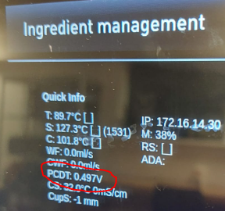

- The screw of the sensor which is placed at the back of the unit
needs to be tightened with a torc of 1,2 Nm
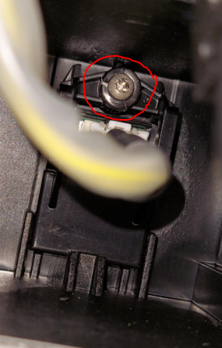

- In case you have no screw driver with torc measurement you can tighten the screw with the empty drip tray inserted until the quick information displays the voltage between 500mV – 600 mV.

