Service memo
3-11-2023

Number: JDE 2023-08
Dispenser(s): SOUL 10-12 self service
Title: 'hole' by second squeeze valve milk hose

With this service memo I would like to inform you that for the SOUL Self Service machine with the next serial numbers it is possible that you find a ‘hole’ on the place for the second squeeze valve for the milk hose like on the picture below. Black part will have the foil as shown on the right side.
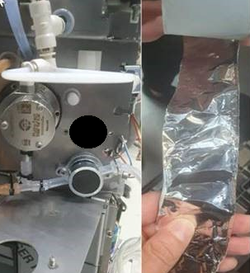
This doesn’t affect the working of the machine but is done in consultation with JDE.
Machine configuration is a ‘real’ SOUL Self Service machine.
Affected serial numbers:
2340679963 | 2341682228 | 2341682238 | 2341682248 | 2341682258 | 2341682268 | 2341682279
2340679964 | 2341682229 | 2341682239 | 2341682249 | 2341682259 | 2341682270 | 2341682280
2340679965 | 2341682230 | 2341682240 | 2341682250 | 2341682260 | 2341682271 | 2341682281
2340679966 | 2341682231 | 2341682241 | 2341682251 | 2341682261 | 2341682272 | 2341682282
2340679967 | 2341682232 | 2341682242 | 2341682252 | 2341682262 | 2341682273 | 2341682283
2340679968 | 2341682233 | 2341682243 | 2341682253 | 2341682263 | 2341682274 | 2341682284
2340679969 | 2341682234 | 2341682244 | 2341682254 | 2341682264 | 2341682275 | 2341682285
2340679970 | 2341682235 | 2341682245 | 2341682255 | 2341682265 | 2341682276 | 2341682286
2341682226 | 2341682236 | 2341682246 | 2341682256 | 2341682266 | 2341682277 | 2341682287
2341682227 | 2341682237 | 2341682247 | 2341682257 | 2341682267 | 2341682278 | 2341682288
 |  |  |  |  |  | 2341682269

