Service memo
1 August 2023

Number: JDE 2023-07
Dispenser(s): Schaerer Coffee Club / SKYE
Title: New outlet for double instant canister 55126774

With this service memo I would like to inform you that there is a new outlet available for the double instant canister for the Schaerer Coffee Club and Skye:
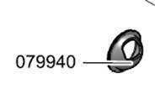
55126774 HOLDER RESTRICTOR TWIN POWDER CONT.
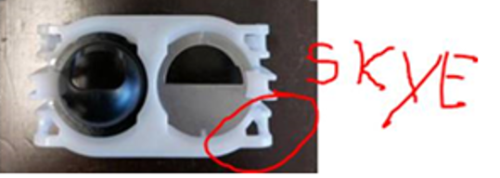 55119520
Outlet restrictor powder container
For the Club you have to modify the spare a little bit as described below:
Current outlet CLUB:
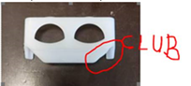
Parts you have to cut away for the CLUB:
