Service memo
14 February 2023

Number: JDE 2023-04
Dispenser(s): Schaerer C60 FRIDGE 2 x 10 litre under counter
Title: Schaerer C60 2 x 10 litre under counter fridge with temporary door

With this service memo I would like to inform you that the 2 x 10 litre under counter fridge (C60) from Schaerer will have temporary a different door.
So it is possible that you will see a non-transparent door instead of a door with clear glass:

Clear glass door: Non-transparent door:
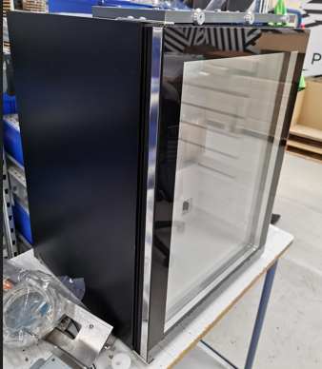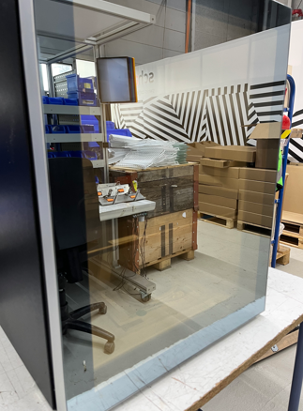
In the future it will be clear glass again.

