Service memo
27 January 2023

Number: JDE 2023-03
Dispenser(s): Schaerer SCS/SOUL 10-12-Barista
Title: Schaerer Coffee Art Best Foam maintenance set best foam blender

With this service memo I would like to inform you that Schaerer decided to phase out the MAINTENANCE SET BLEN DER SCA BF, SAP number: 55119772.
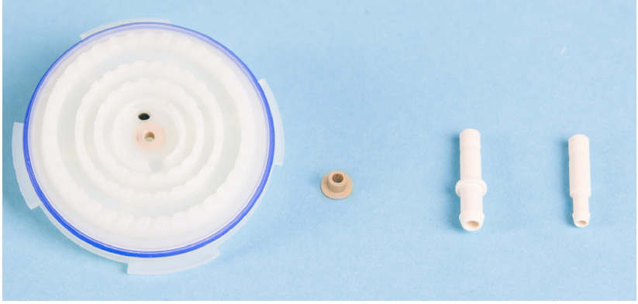
There is no replacement for this as Schaerer will introduce an improved Best Foam blender.
As soon as thereis a timing when this will be introduced I will inform you.

