Service memo
2 December 2022

Number: JDE 2022-08
Dispenser(s): SOUL 10-12-Barista
Title: Special released software 4.44.10

With this service memo I want to inform you that with software 4.44.10 Schaerer released a new software to solve the cleaning problem for the flavour unit. Unfortunately 3 other problems are still in, see sum up below:

- Freezing of the screen by cancelling the drink is not solved, this will be solved in the next software release and that is in January 2023.
Intermediate solution for this is swopping the extra shot in coffee see instruction below:
This has to be done in all coffee’s if there is an optional step.

Situation now: After swop:
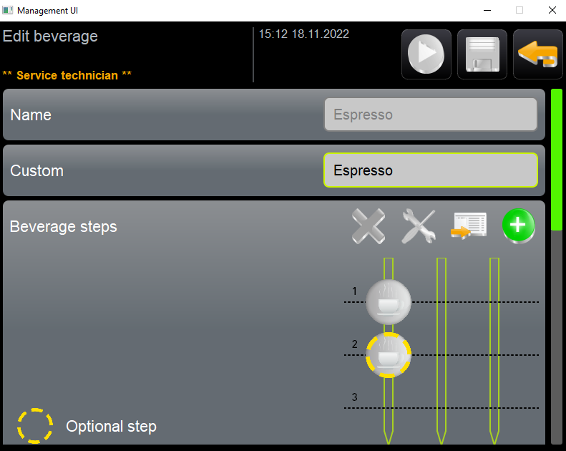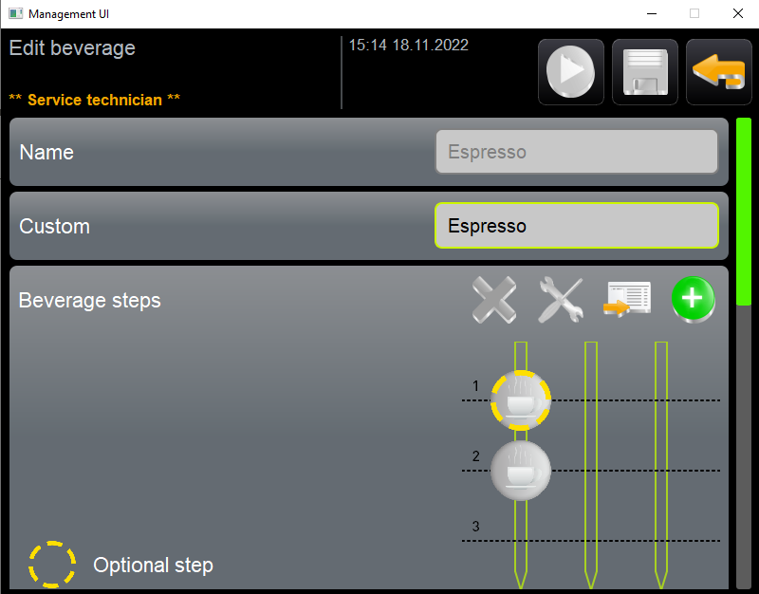

- With this software version it is needed that after calibration of the grinders the machine has to be restarted by hand as it is not done automatically with this version. This has to be done otherwise the calibration is not saved.
Will be solved in next software release and that is in January 2023.
- Automatic ON/OFF is not working at all so don’t use this. This problem will be solved Q1 2024 (not a mistake). Reason for this is that it needs a hardware change

