Service memo
03 November 2022

Number: JDE 2022-07
Dispenser(s): SOUL 10-12-Barista
Title: New media packages;

With this service memo I want to inform you that on JDE support next items are published:

- Media packages with video changed;
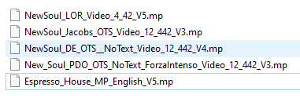

These media packages are updated because of size video.

