Service Memo |  | 2020-001
Machine: | Barista One / Schaerer Coffee Prime
Titel: | CONVERSION NEEDLE VALVE SET SCP/BO

Dear All,

Hereby I want to inform you that we now have available a CONVERSION NEEDLE VALVE SET SCP/BO to relocate the air needle valve. Sometimes the air valve deviate and with this kit you can relocate the air valve to avoid deviation.
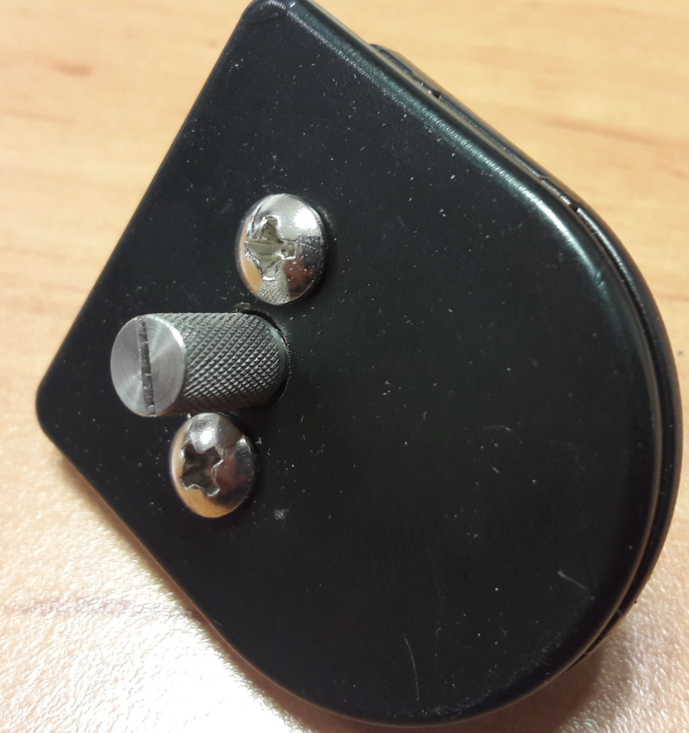 Order number will be: 55121749

The relocation will be from behind the bean container into the place of the instant product motor, see pictures below. Be Aware that this is only possible if you have no instant or 1 instant canister.

