Service Memo |  | 2019-012
Machine: | Barista One / Schaerer Coffee Prime
Titel: | Advice how to exchange boiler

Dear All,

Hereby I want to inform you what the best way of working is by exchanging boilers in the Barista One / Schaerer Coffee Prime.

There are 2 ways of working:

A: machine is still working
B: machine is out of order

Way of working A machine is still working:
- Go into the menu for service technician
- Step to: set up; service; start drainage
- Follow the steps on the screen, as soon as drainage is done take out the power plug of the machine from the wall socket and change the boiler(s)
- After changing the boiler put in the power plug of the machine into the wall socket and follow the steps in the screen.
Machine will make a commissioning and fill up the boiler(s).
- Ready.

Way of working B machine is out of order:
- Check if the power plug of the machine is out the wall socket.
- Exchange the boiler(s)
- Don’t connect the wires on the solid state relays in the back of the machine so the machine can’t heat up when switched on, see picture below:
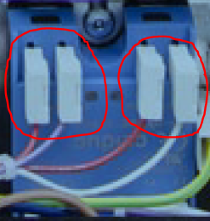
- Put the power plug of the machine into the wall socket.
- As soon as the boiler is filled up take out the power plug of the machine from the wall socket and connect the wires which are not connected in point 3.
- Put the power plug of the machine into the wall socket.
- Ready

