IMPORTANT Service Memo Instruction which machine to check resistor cable fan |  | 2019-011
Machine: | Barista One / Schaerer Coffee Prime
Titel: | Instruction which machine to check/replace/place resistor cable fan

Dear All,

This is an instruction about which machines to check the resistor cable of the fan.
The new number for the WHITE cable is: 55121551/ 075251 ADAPTER CABLE FAN BO/SCP NEW

Also check all local stock locations and throw away the cables with the BLACK and RED isolation.
RED isolation should also to be replaced as the WHITE one is performing better.

BLACK isolation is INCORRECT : RED isolation is INCORRECT :
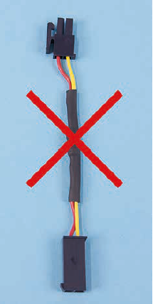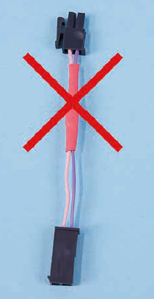

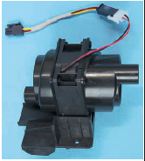
WHITE isolation is CORRECT :

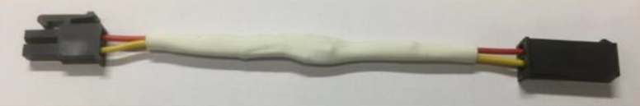

The machines already placed in the markets needs to be updated with the new WHITE cable as following:

Priority 1: Machines produced in CW 31 – 45 (serial no.’s are: 1931… - 1945…) need to be updated first.
These machines has to be visited pro-active within 3 weeks after receiving the WHITE cable.
Take in account what is feasible but it is strongly recommended to complete this action within
these 3 weeks.

Priority 2: Machines produced in CW 01 – 30 (serial no.’s are: 1901… - 1930…) can be updated during a
regular service visit.

All machines on stock with serial no. up to 1945….. need to be updated with the new WHITE cable before placed at customers. As we already informed in the service memo 2019-010 we advise to do this during installation. Be aware that in this memo is mentioned that the RED cable is ok but this one has also to be replaced for the WHITE cable.

Machines produced from CW 48, (serial no. 1948…….) will have the right WHITE cable in the machine.

Instruction how to place the WHITE cable, see next pages.

Dismantle:

For the Barista One first take of the bean container.

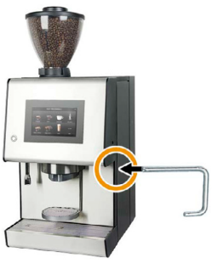
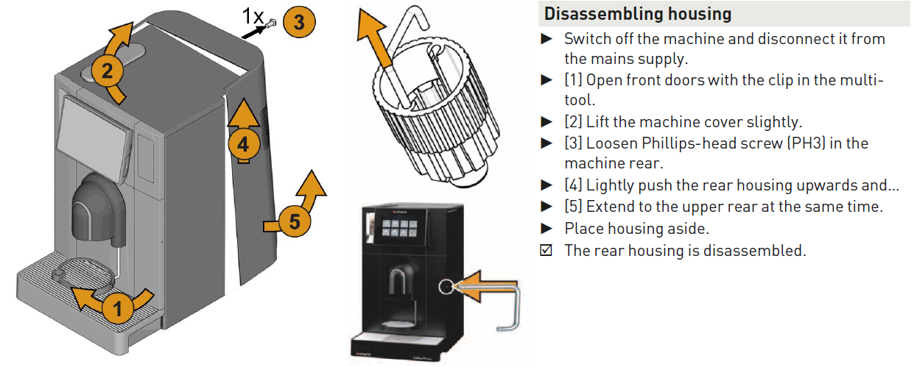

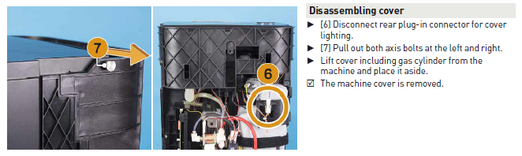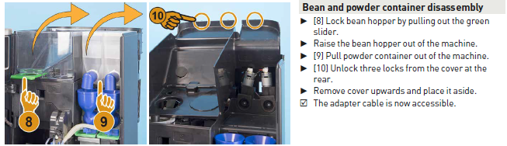
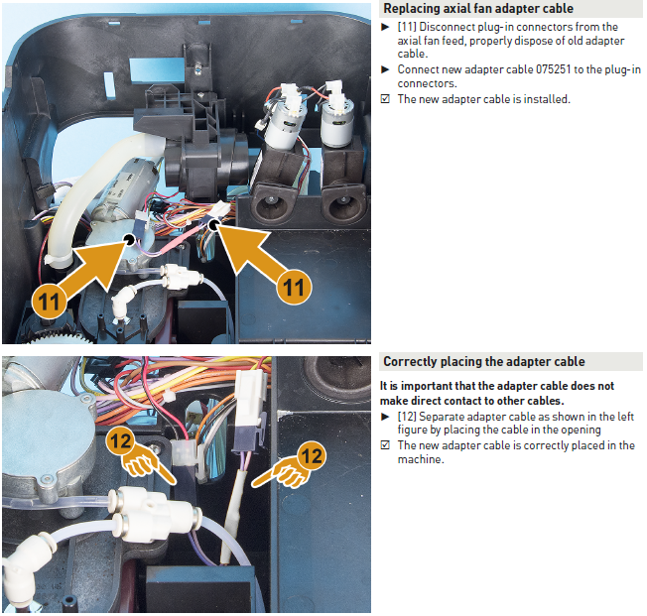

Last Step:

Rebuilt all steps backwards.
If you have replaced the cable with the BLACK or RED isolation don’t forget to make a picture of the cable including the serial number of the machine and send this picture to your technical manger to collect these and send this information to the responsible customer support manager from the global department.

