IMPORTANT Service Memo Installation and service check instruction |  | 2019-010
Machine: | Barista One / Schaerer Coffee Prime
Titel: | Instruction how to check resistor cable fan

Dear All,

This instruction shows you how to check the resistor cable (075183/55120757) for the fan in the Barista One / Schaerer Coffee Prime.
Also check all local stock locations and throw away the cables with the BLACK isolation.

BLACK isolation is INCORRECT : RED isolation is CORRECT :

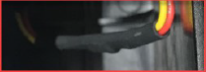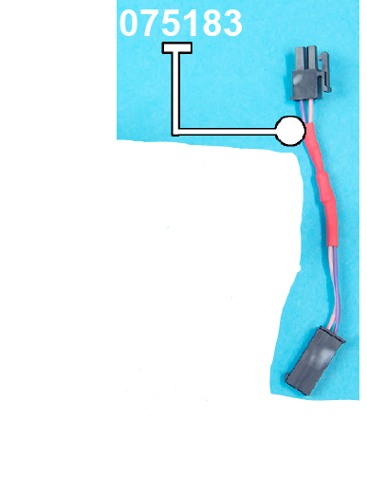

At the beginning of an installation or a service visit check if the serial number of the machine is in between the range starting with 1932…. up to 1944…..

If in between take the next steps:

Dismantle:
Take out the plug of the machine. To open the front door, take a small screwdriver or the special tool and push it into the hole on the right machine side, push it to the mechanism, so that the door opens.

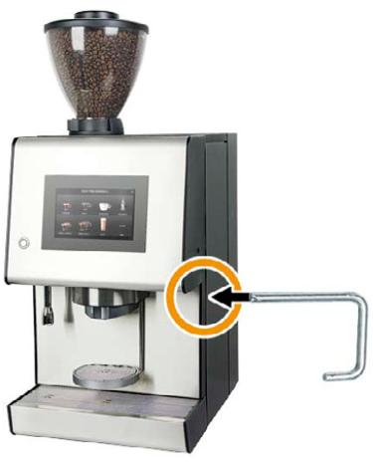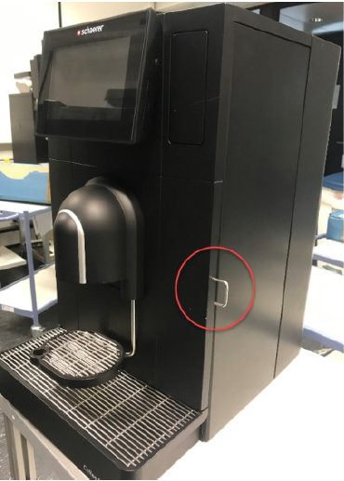
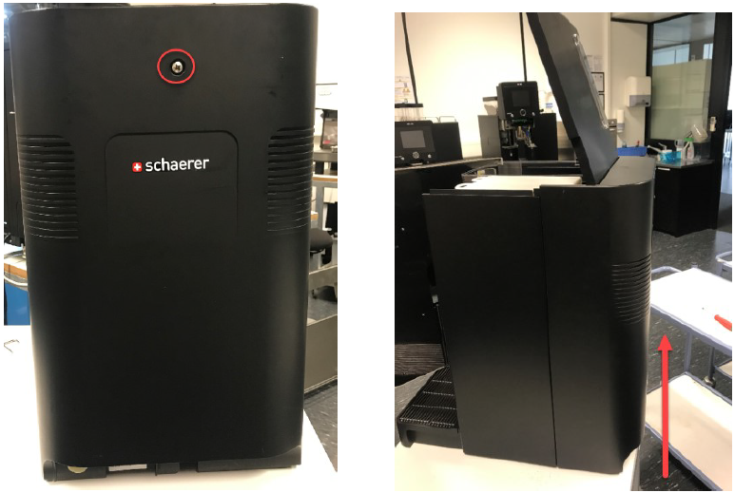

Take out the screw of the rear panel and open the lid (with Barista One first take of the bean container), if the lid is open, lift the rear panel and remove it.

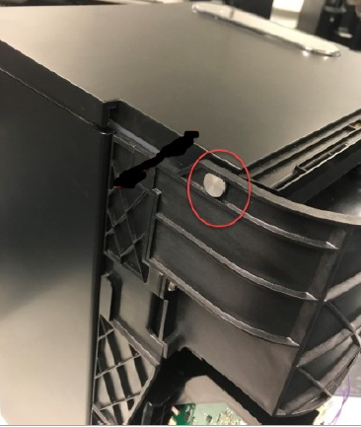
There are two bolts on each side of the machine; they are connected with the top cover. Take them out, take out the cable plug on the right side (Barista One doesn’t have this) and take off the top cover.
Take out the topping container, take out the coffee container and take out the complete black plastic cover. Finally, it should have the view as the picture left.

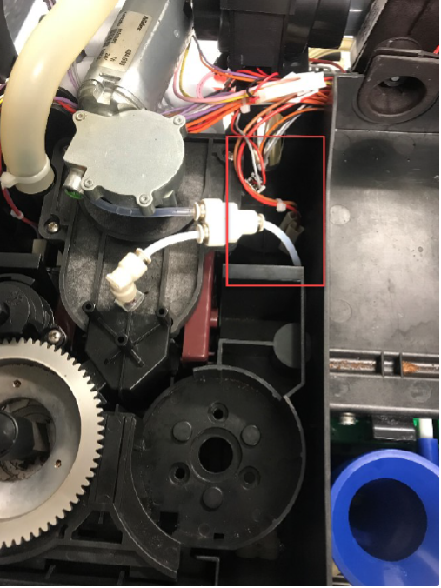
The resistor is placed at the open space of the 2nd grinder, as shown on the picture left in the red box.

Visual check:

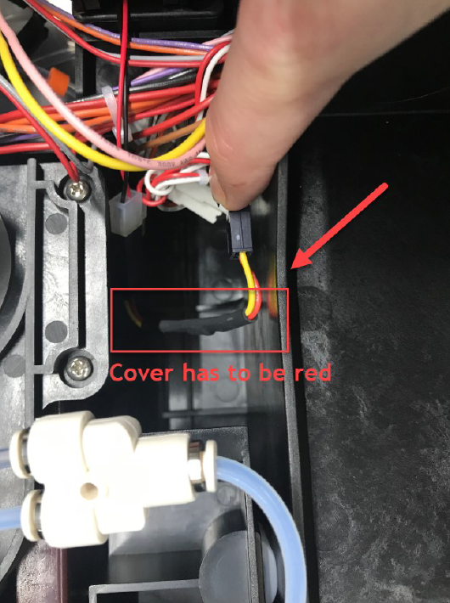
Check that the resistor is placed in the open area and is not in contact with other cables.
- If the isolation of the resistor is RED it is correct. Leave it in the machine.
- If the isolation of the resistor is BLACK, as shown on the left picture remove the cable and replace it with a cable with RED isolation. If you have the cable with the RED isolation not on stock leave the cable out and place it during the next service visit. It is okay that the fan is running without protection.

Last Step:

Rebuilt all steps backwards.
If you have taken out or replaced the cable with the BLACK isolation don’t forget to make a picture of the cable including the serial number of the machine and send it to your technical manger to collect these.

If the cable with the BLACK isolation is removed, but the cable with the RED isolation is not yet installed please log this in the machine so with next service visit this can be installed.

