Service Memo |  | 2019-009
Machine: | Schaerer Coffee Art / Schaerer 500 / Schaerer Coffee Celebration
Titel: | Brewer motor 36 VDC

Dear All,

Hereby I want to inform you that it is possible that if you order brewer motor 55026937, which is actually the brewer motor for the Schaerer Coffee Celebration under, you could receive next on:
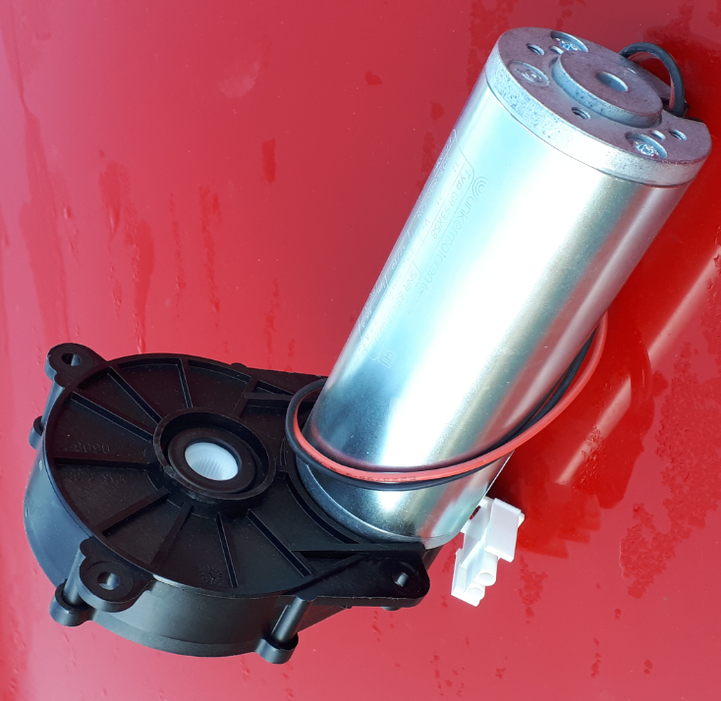
This one is for the Schaerer Coffee Quattro machine which we don’t have in our portfolio.

Please send the wrong motor attended to me so I can arrange the right one for you.

As per direct I blocked spare part number 55026937 in our system and it will not be orderable anymore.
The right (replacement) brewer motor to use is: 55024981.

Hope I inform you sufficiently.

Regards,
Bart Bakker

Address:

Jacobs Douwe Egberts
Attn. Bart Bakker; Dutch Blend 3rd Floor
Vleutensevaart 35
Utrecht 3532 AD
The Netherlands

