Service Memo |  |  | 2019-006
Machine: | Schaerer Coffee Art BF
Titel: | Schaerer Coffee Art BF INSERT BEVERAGE OUTLET WELDED: 55121245 (075139 )

Dear All,

With this service memo I want to inform you that the Insert beverage outlet BF 074408 is changed into INSERT BEVERAGE OUTLET WELDED 075139 with Sap number : 55121245:
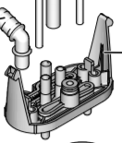

Introduced since week 22.
Problem was that there was a possibility that the outflow for the double cup was not equal.
They changed the way of production to solve this.

