Service Memo |  | 2019-001
Dispenser: | Barista Professional (Best Foam)
Title: | Barista Professional payment in combination with telemetry

The Barista Professional machine with payment in combination with ATTO unit (telemetry) is only working with the BOARD INTERFACE DE-BP (073840) 55115646 from revision D onwards. In combination with PICO it works fine with older boards.
You can check the revision version on the board shown as below:

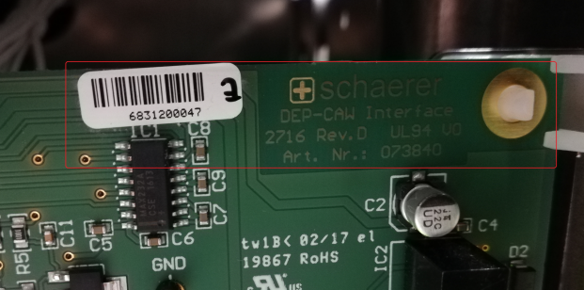

Below advice what to do in described situation:

- For machines produced before 06-2016 which has to be changed to an ATTO please check if the BOARD INTERFACE DE-BP is revision D or higher. If not first change board.
- For machines produced after 06-2016 and up to week 32 2018 BOARD INTERFACE DE-BP revision D or higher should be in but by changing to ATTO please also check.
- For machines produce after week 32 2018 revision D or higher is in.(serial number 1833………)

If you have used machines as point 1 or 2 please check before shipping the machine to the customer.

