Service Memo | 2018-002
Dispenser: Schaerer Soul
Title: Extra information with respect to Best Foam machine settings for SOUL

Hereby some extra information with respect to settings for the SOUL with respect to Best Foam:

- Don’t change anything with the Best Foam parameters in the program:
  - Best Foam parameter: Pre warming time is time (duration) that water is rinsing into the drain.
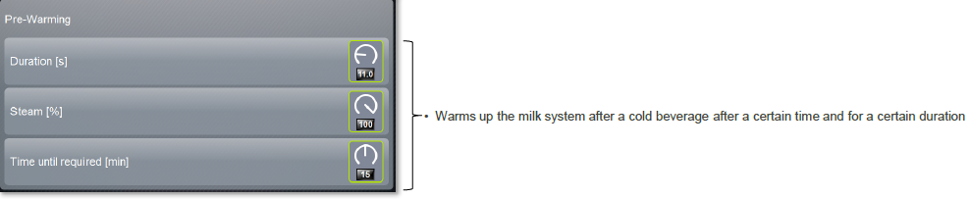

- Milk system: milk container hose length; this is the length from squeezer valve and the point where the hose enter the cooling cell of the fridge:
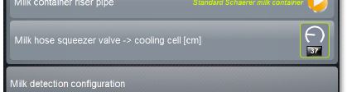
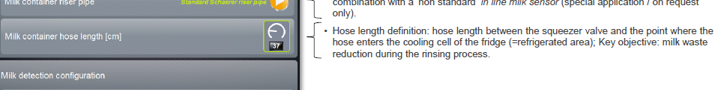

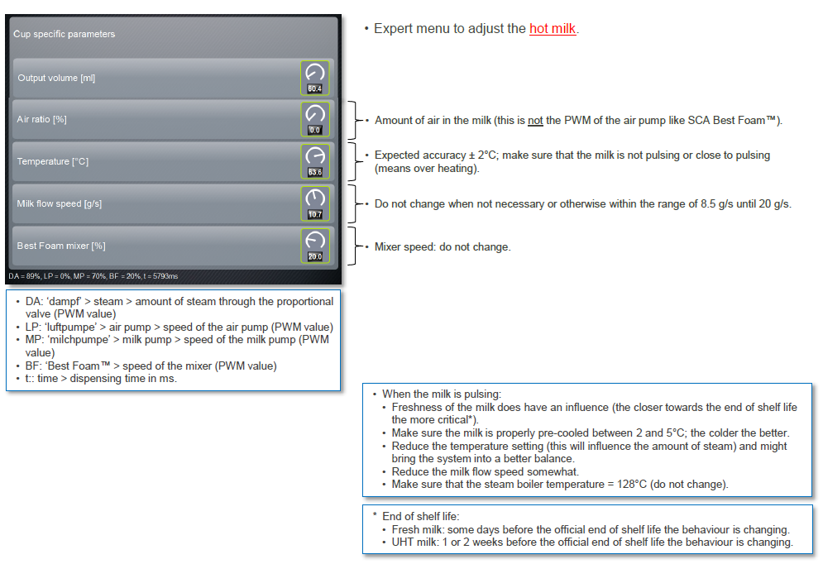
- Important to know what happens when changing settings in beverage recipe:

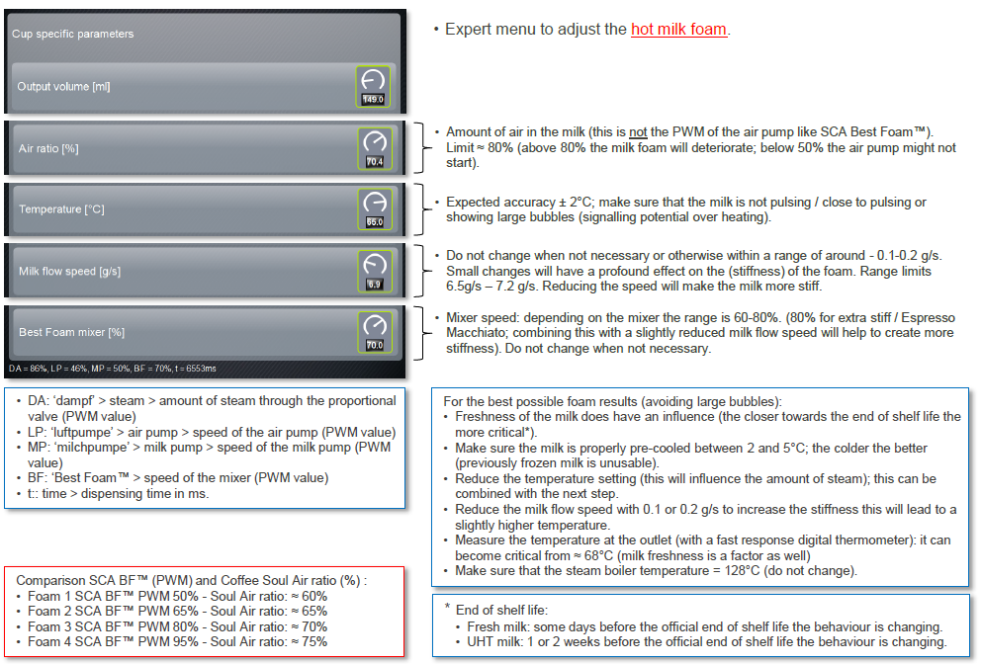

Be aware of the difference in setting between SCA BF and SOUL

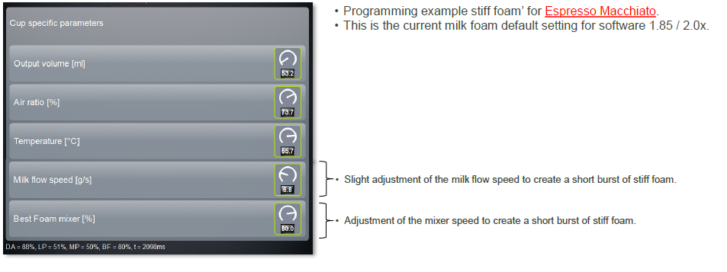

- Information with respect to master reset especially point 3:
