Service Memo |  | 2018-001
Dispenser(s): Schaerer Soul
Title: Changed outlet instant container

The outlet of the instant container of the SOUL has been changed to prevent that instant ingredient drops out.

Part no. Description SAP No.
33.2293.7000 Restrictor powder cont. outlet 55119520

The new outlet is installed from serial number 1834612458 (Production is in week 34)

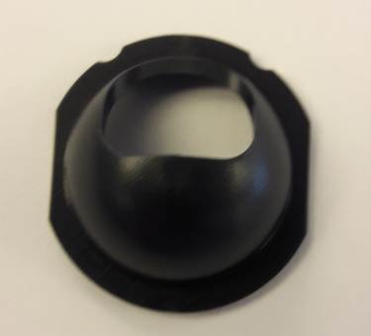g

