Service memo
22 may. 2023
3

Number: 2023-05
Dispenser(s): Omni table top
Title: Leaking ingredients containers

Background:

In some machines instant ingredient is found on the ingredient table.
This results in extra maintenance time.

This leakage is caused by a sticking out locking pin of the worm wheel.
It will probably be pushed out if you forget to place the spout correctly after filling the canister.
Once the locking has been pushed out ingredient powder can enter the shaft of the worm gear, making it impossible to push the locking pin back to its original position.

Action:

If during a regular service or operating visit it is found that the locking pin sticks out:
Remove the locking pin, remove ingredient from the shaft of the worm wheel and remount the locking pin.

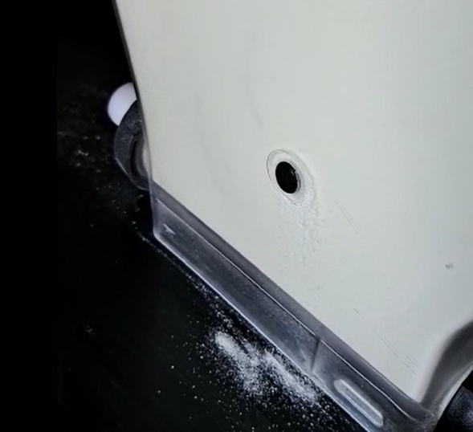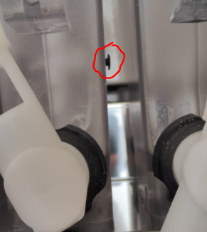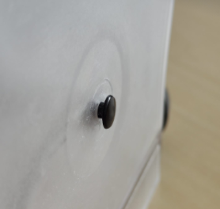

Shaft filled with ingredient:

