Service Memo |  | 04-03-2020
Dispenser(s): | Kalea Plus_Omni XL
Title: | Z4000 brewer in cup quality improvements

Background:

With the introduction of some new Evoca equipment within JDE containing the regular 46mm Z4000 brewer, we see that the in-cup quality and taste is not matching with the JDE standards.
For this reason we are introducing several improvements together with Evoca.

Standard Solution:

Standard the Z4000 brewer comes with a regular outlet on the brewer and a standard upper piston sieve.
- We noticed that with especially Nordic settings the in-cup quality (crema) is very poor
- We noticed that the taste of the coffee is more “dusty”

Solution JDE variants:

From factory the Omni XL and Kalea plus will be delivered with a 0.7mm stainless steel restrictor in the brewer outlet.
This to improve the crema layer (part number 55119523 NEW COFFEE OUTLET)

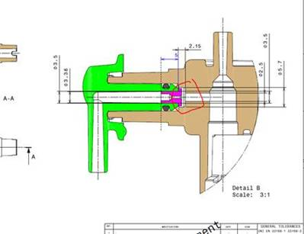

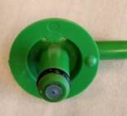

Especially on the Kalea Plus with using a finer grind course and Nordic settings we see that sometimes the new restrictor is being clogged. This is caused by the upper sieve of the brewer (fine particles are passing the sieve and are swelling afterwards)

Also we have seen that the sieve is causing a more “dusty” taste on the coffee.

Solution:

The Espresso Omni XL and Kalea are delivered already starting from JDE introduction with the new coffee outlet with restrictor.
Temporarily solution is to mount a Egro sieve in the upper part of the Z4000 Brewer with new Kalea introductions, and with problems in the field by Espresso Omni XL this can also be used.
The part number is 55029315 BREWING SIEVE Ø 44 MM WITH SCREW.
In the meantime Evoca is looking for a final solution in production, timing will follow.

